Earthquake Monitor

# Description:

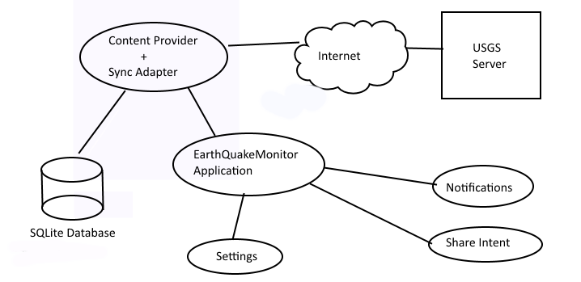

Figure 1: Overview

The earthquake monitor android application provides user to visualize up-to-date earthquakes events published by USGS web site. This includes viewing the events as list and located in a map. For each entry in the list detail view is provided with location focused on map and with more details of the event.

The application helps the user to easily identify significant event by providing coloured icon according to significance and the alert level defined by USGS data feed as illustrated below.

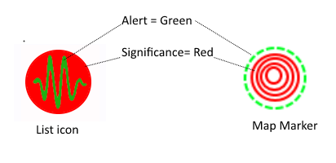

Figure 2: Event illustration with USGS parameters

User has the ability to filter only significant events which can be customised by settings where result is reflected in both event list and the map. The content of the event can be shared using a selectable application which includes an URL to the USGS web page describing the event in detail.